**Fish Graphs for NOAA Report Card - Emma Beretta**

What is the seasonality of fish choruses on the West Coast?

**CH01:**

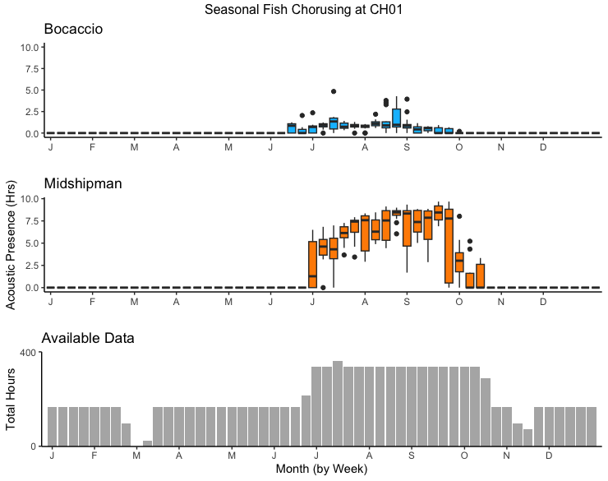

Figure 1. Distribution of fish chorusing hours for each week in the year for site CH01 in the Chumash Heritage National Marine Sanctuary. Fish species Bocaccio (blue) and Plainfin Midshipman (orange) were identified at CH01 between June 2022 and November 2023 with some data gaps between recordings, as seen in the available data histogram of total recording hours for each week of the year.

**MB01:**

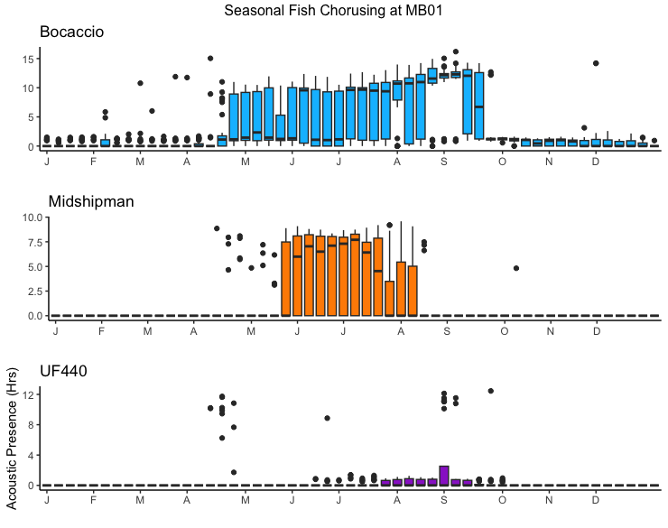

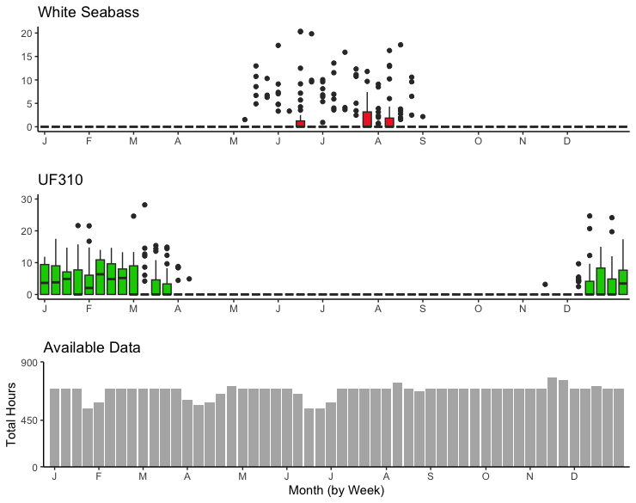

Figure 2. Distribution of fish chorusing hours for each week in the year for site MB01 in the Monterey Bay National Marine Sanctuary. Fish species Bocaccio (blue), Plainfin Midshipman (orange), White Seabass (red boxplots), UF440 (purple), and UF310 (green) were identified at MB01 between November 2018 and August 2023. There were some data gaps between recordings, as seen in the available data histogram of total recording hours for each week of the year.

**MB02:**

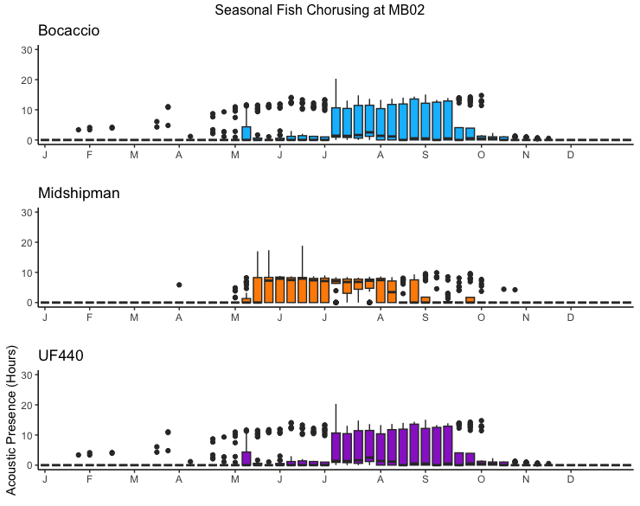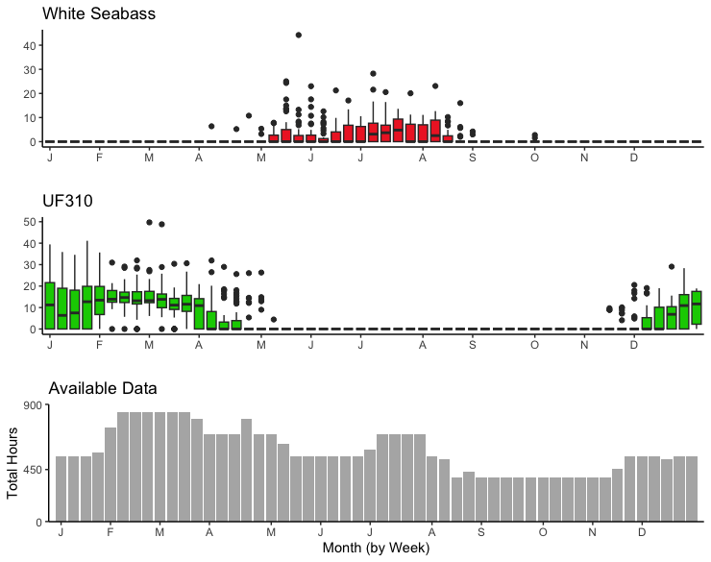

Figure 4. Distribution of fish chorusing hours for each week in the year for site MB02 in the Monterey Bay National Marine Sanctuary. Fish species Bocaccio (blue), Plainfin Midshipman (orange), White Seabass (red boxplots), UF440 (purple) and UF310 (green) were identified at MB02 between November 2018 and July 2023. There were some data gaps between recordings, as seen in the available data histogram of total recording hours for each week of the year.

How does the most recent year of fish chorusing vary from previous seasons?

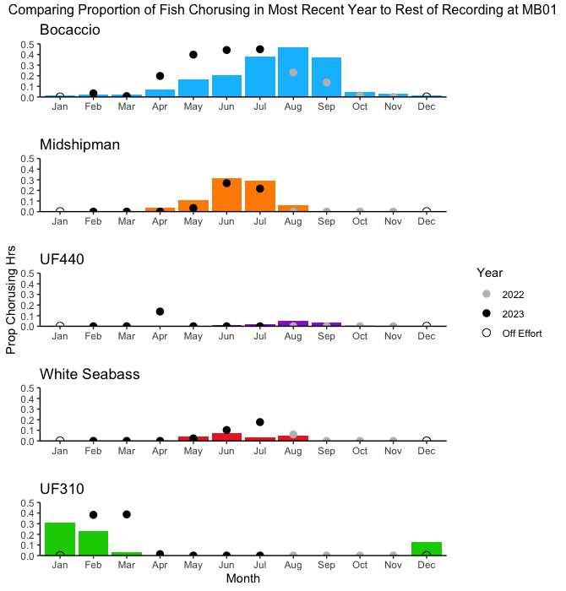

Figure 3. Bars represent total fish chorusing / total recording hours for each month between January of 2019 and December of 2021 (the proportion of chorusing). Dots plotted for each month represent the proportion of chorusing from the most recent year of data, from August 2022 to July 2023. Grey dots indicate that month of recent data was from 2022, black dots indicate that month of recent data was from 2023, and empty dots indicate off effort (no data).

What is the diel nature of these choruses?

**CH01:**

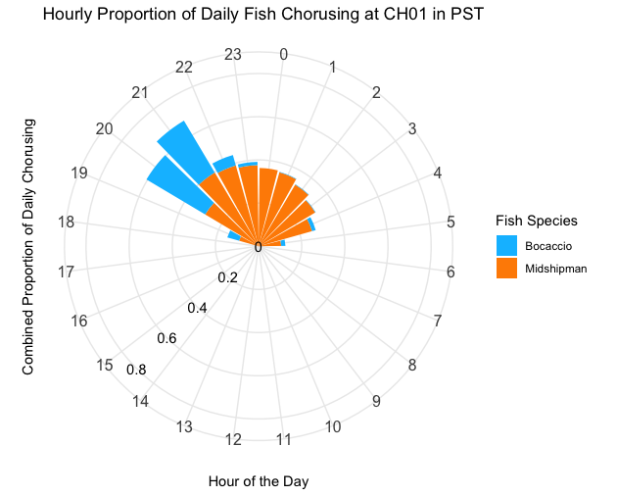

Figure 5. Combined proportion of fish chorusing for each hour in the day (Pacific Standard Time) calculated by computing total days when fish sang during a certain hour / total days spent recording during that hour at CH01 in the Chumash Heritage National Marine Sanctuary. The orange bars indicate the proportion of chorusing during that hour for Plainfin Midshipman and the blue bars indicate the proportion of chorusing during that hour for Bocaccio.

**MB01:**

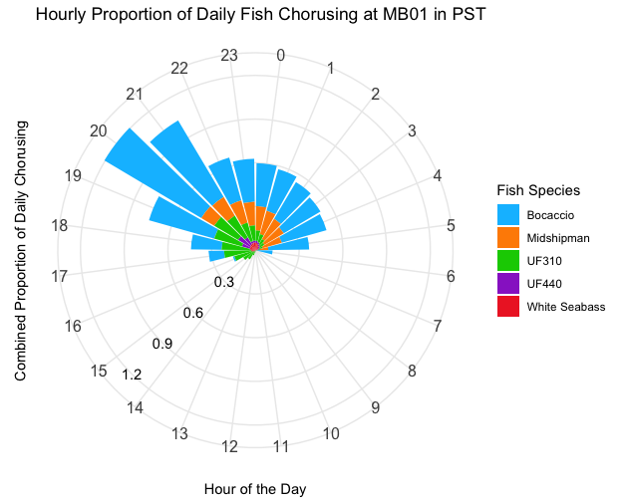

Figure 6. Combined proportion of fish chorusing for each hour in the day (Pacific Standard Time) calculated by computing total days when fish sang during a certain hour / total days spent recording during that hour at MB01 in the Monterey Bay National Marine Sanctuary. The orange bars indicate the proportion of chorusing during that hour for Plainfin Midshipman, the blue bars for Bocaccio, the green bars for UF310, the purple bars for UF440, and the red bars for White Seabass.

Where are we hearing fish chorusing in the California sanctuaries?

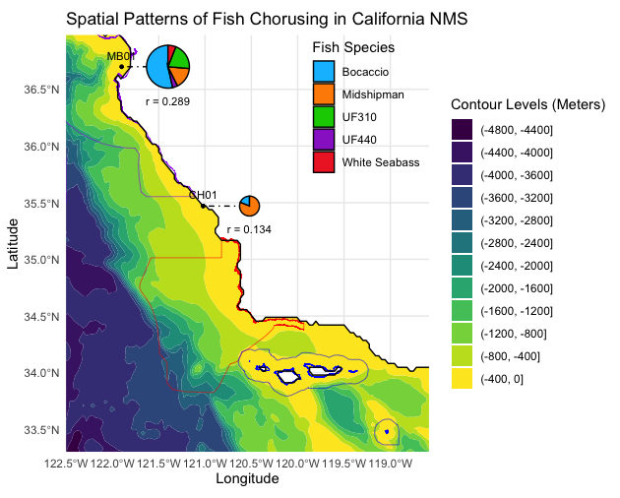

Figure 7. A bathymetric map of the central california coast showing changes in ocean floor depth every 400 meters, from sea level to 4800 m, with outlines for the National Marine Sanctuaries (Channel Island is blue, Chumash Heritage is red, and Monterey Bay is purple. White areas of the map indicate land, yellow areas are the shallowest parts of the ocean, and dark blue are the deepest. Black dots indicate recording site latitudes and longitudes and are connected to a pie chart showing what types of fish were heard at that site. Orange slices of the pies show how much of the total fish chorusing we heard at that site was from Plainfin Midshipman, blue slices are for Bocaccio, green for UF310, purple for UF440, and red for White Seabass. The pie charts with a smaller radius (r) have less available data than those with a larger radius, meaning that we recorded for less time at those sites.